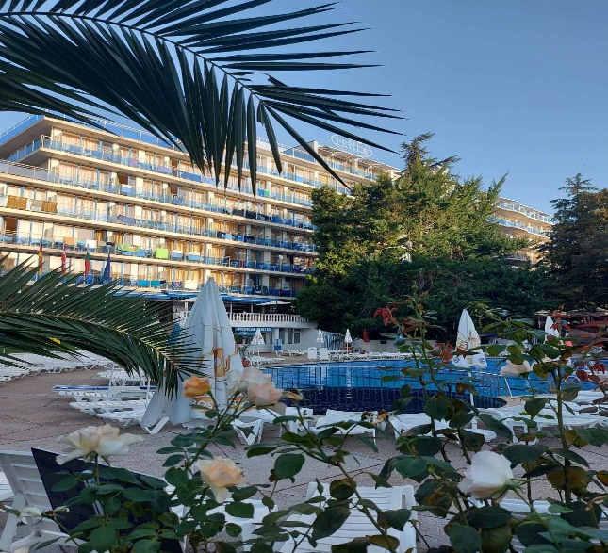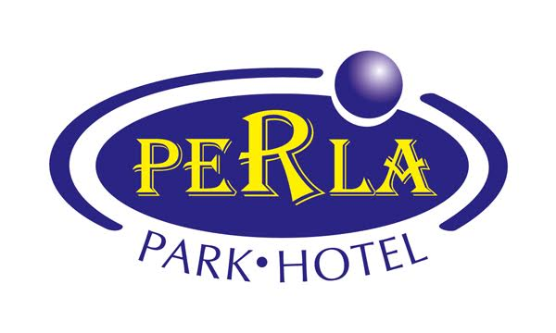

ALL INCLUSIVE PROGRAM
Hotel Perla, Golden Sands
Season 2024
Restaurant
Breakfast: 07.30 - 10.00 – Buffet / Main Restaurant
Lunch: 12.30 - 14.00 – Buffet / Main Restaurant (variety of Bulgarian and international dishes)
Dinner: 18.00 - 20.00 - Buffet / Main Restaurant (variety of Bulgarian and international dishes)
Snack: 16.00 – 17.00 – Main Restaurant – cake, cookies, coffee

All inclusive drinks - 11.00h and 22.30h
Only in special „All inclusive Bar“ in the main restaurant.
Lobby- and pool bars are not included in the program.
DRAFT ALCOHOL- FREE DRINKS:
Local soft drinks, Mineral Water,
Soda Water, Juice-Punch - local
DOMESTIC ALCOHOLIC BEVERAGES:
Spirit drinks / local / - white bracelets
Draft Beer, Red and White Dry and Semi-dry Wines
HOT DRINKS:
Coffee Espresso, Cappuccino, Nescafe, Milk,
Cocoa Milk, Tea – Black

